John Michael Go
Career Entry Level Java Programming
Date: Jan. 11, 2013

DAY 1

Program Name: NameAge

Objective: Input user name and age and system will display it

Algorithm:

- User inputs name
- User inputs age
- Program will display sentence with name and age included.

Flowchart:

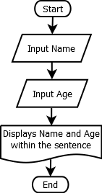

Pseudocode:

import java.util.*;

public class NameAge {

public static void main (String[]args){
// declaration of variable
Scanner console = new Scanner(System.in);
String name;
int age;
// enter name
System.out.println ("");
System.out.print("What is your name ? ");
name = console.next();
System.out.println ("");
// enter age
System.out.print ("How old are you ? ");
age = console.nextInt();
System.out.println ("");
System.out.print("");
System.out.println ("===============================================================================");
System.out.println ("");
System.out.println ("Hello there " + name + " so you are already " + age + " years old");
System.out.println ("");
System.out.println ("");
System.out.println ("");

}

}

Screenshot:

